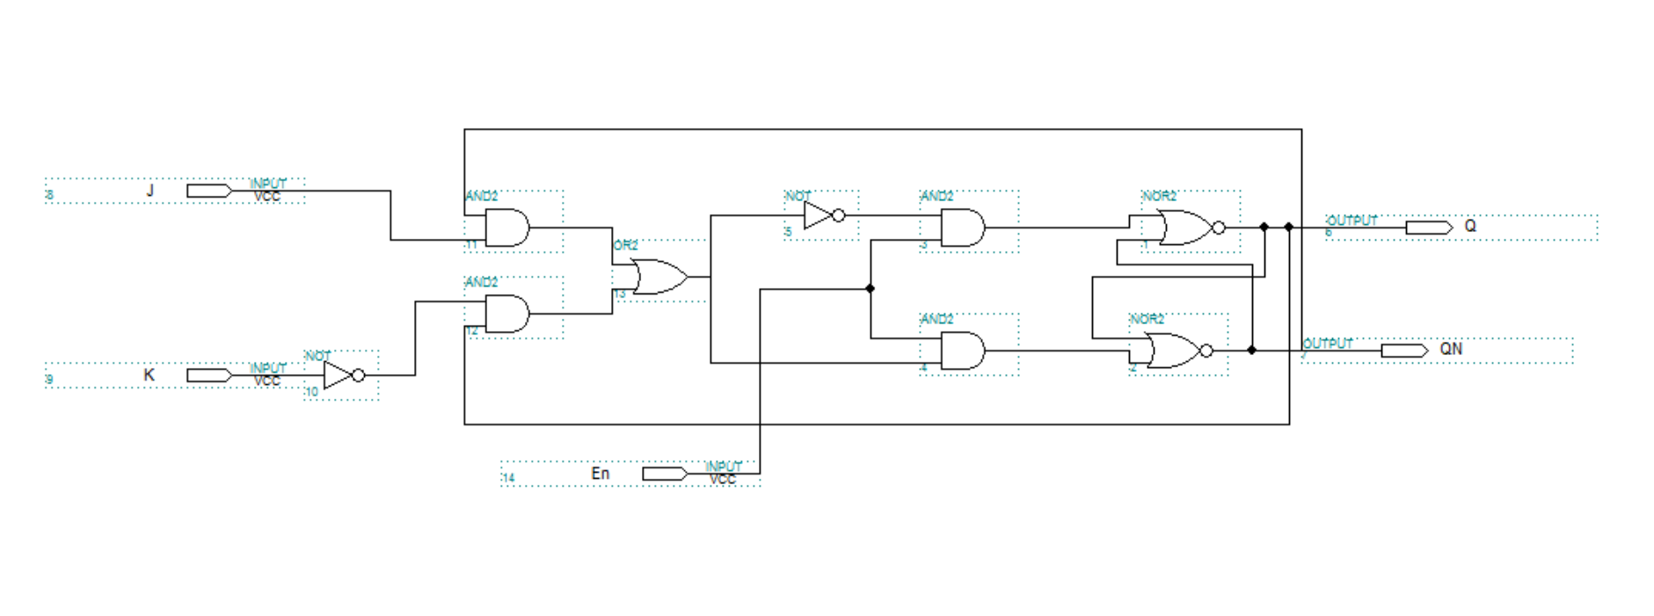**Latch Conversion Process**

Patsakorn Towatrakool

590610644

**SR Latch**

(SRLatch.v)

**D Latch**

(DLatch.v)

**JK Latch**

(JKLatch.v)

**QN**

**Q**

Qt-1

QNt-1

w_not1

w_and2

w_and1

not1

and2

and1

nor1

not1

or1

**QN**

**x**

**Q**

**x**

**K**

**J**

nor2

QNt-1

and1

and2

w_not1

**D**

**D**

**En**

QNt-1

Qt-1

**QN**

**Q**

**S**

**R**

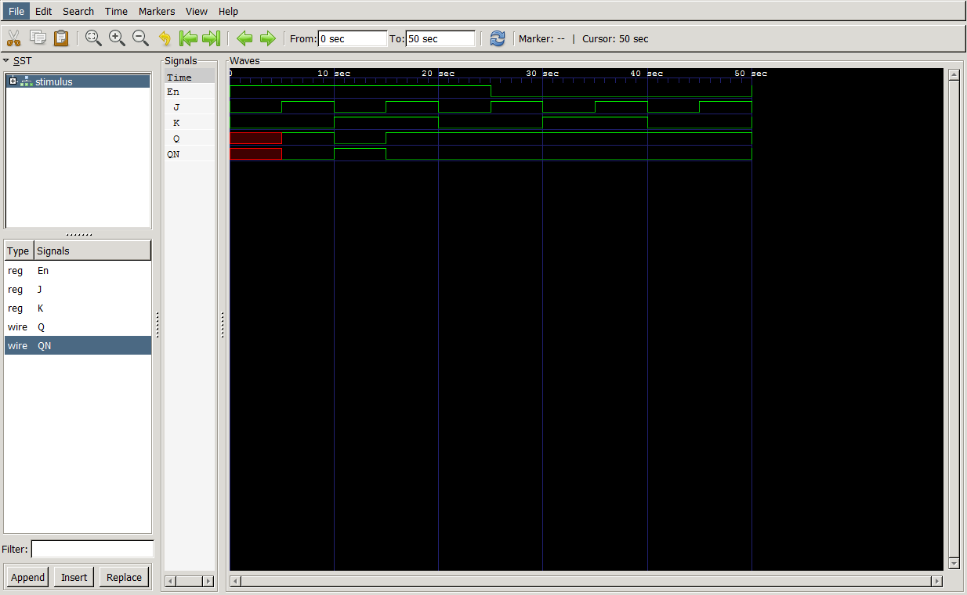**JK Latch Timing Diagram**

**Patsakorn Towatrakool**

**590610644**